Actividad 8 - Relaciones ternarias
Wuke Zhang 1-ASIR

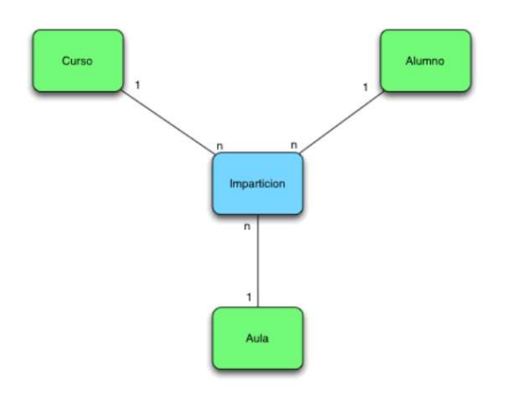

Indice:

Portada ………………………………………………………………………………………………………1

Indice …………………………………………………………………………………………………… 2

Introduccion …………………………………………………………………………………………………… 3

Resolucion …………………………………………………………………………………………………… 4

Conclusion …………………………………………………………………………………………………… 5

Bibliografia …………………………………………………………………………………………………… 6

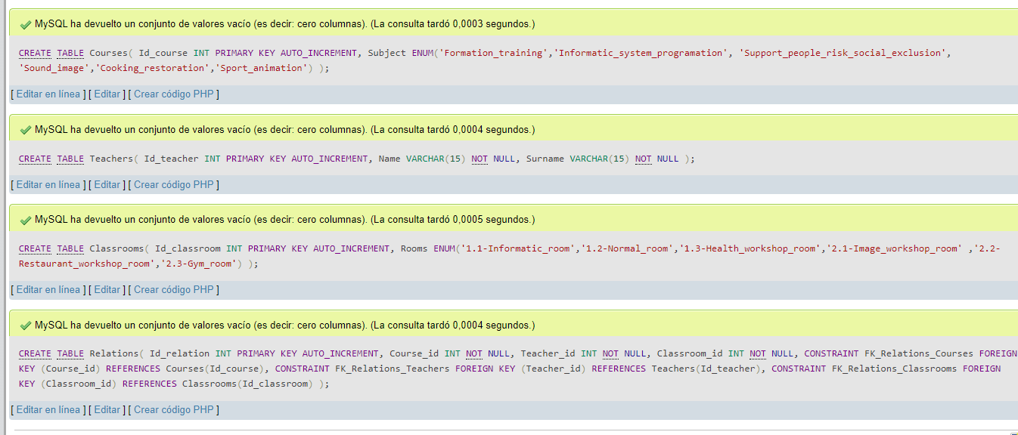
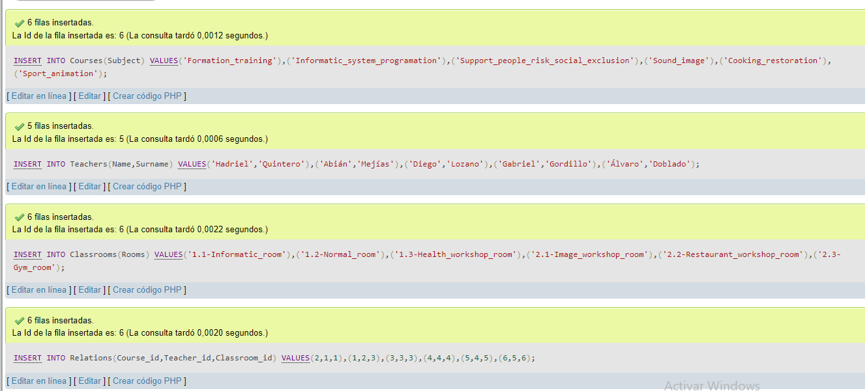
CREATE DATABASE Actividad8;

USE Actividad8;

CREATE TABLE Courses(
Id_course INT PRIMARY KEY AUTO_INCREMENT,
Subject ENUM('Formation_training','Informatic_system_programation', 'Support_people_risk_social_exclusion',
'Sound_image','Cooking_restoration','Sport_animation')
);

CREATE TABLE Teachers(
Id_teacher INT PRIMARY KEY AUTO_INCREMENT,
Name VARCHAR(15) NOT NULL,
Surname VARCHAR(15) NOT NULL
);

CREATE TABLE Classrooms(
Id_classroom INT PRIMARY KEY AUTO_INCREMENT,
Rooms ENUM('1.1-Informatic_room','1.2-Normal_room','1.3-Health_workshop_room','2.1-Image_workshop_room'
,'2.2-Restaurant_workshop_room','2.3-Gym_room')
);

CREATE TABLE Relations(
Id_relation INT PRIMARY KEY AUTO_INCREMENT,
Course_id INT NOT NULL,
Teacher_id INT NOT NULL,
Classroom_id INT NOT NULL,
CONSTRAINT FK_Relations_Courses FOREIGN KEY (Course_id)
REFERENCES Courses(Id_course),
CONSTRAINT FK_Relations_Teachers FOREIGN KEY (Teacher_id)
REFERENCES Teachers(Id_teacher),
CONSTRAINT FK_Relations_Classrooms FOREIGN KEY (Classroom_id)
REFERENCES Classrooms(Id_classroom)
);

INSERT INTO Courses(Subject)
VALUES('Formation_training'),('Informatic_system_programation'),('Support_people_risk_social_exclusion'),('Sound_image'),('Cooking_restoration'),
('Sport_animation');

INSERT INTO Teachers(Name,Surname)
VALUES('Hadriel','Quintero'),('Abián','Mejías'),('Diego','Lozano'),('Gabriel','Gordillo'),('Álvaro','Doblado');

INSERT INTO Classrooms(Rooms)
VALUES('1.1-Informatic_room'),('1.2-Normal_room'),('1.3-Health_workshop_room'),('2.1-Image_workshop_room'),('2.2-Restaurant_workshop_room'),('2.3-Gym_room');

INSERT INTO Relations(Course_id,Teacher_id,Classroom_id)
VALUES(2,1,1),(1,2,3),(3,3,3),(4,4,4),(5,4,5),(6,5,6);

//*All the relations with his respective info*//
SELECT Subject,Id_teacher,Name,Surname,Rooms,Id_relation FROM Relations
JOIN Courses ON Id_course = Course_id
JOIN Teachers ON Id_teacher = Teacher_id
JOIN Classrooms ON Id_classroom = Classroom_id

